**20277 מערכות בסיסי-נתונים‏  
4 נקודות זכות ברמה רגילה**

פתרון שאילתות SQL מבחנים וממנים

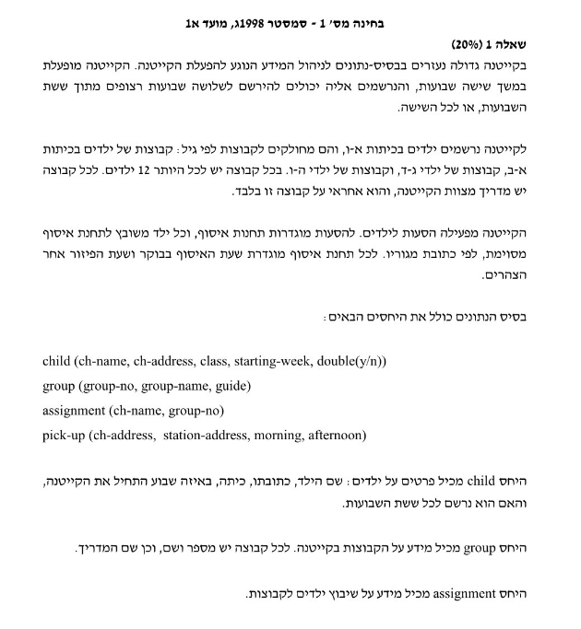

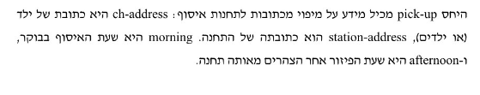

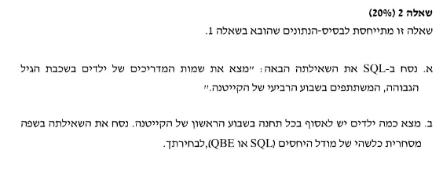

הדבר הכי טוב במבחן הוא למלא טבלאות , יש לנו זמן במבחן לעשות כך:

**Child:**

**Name , ch_address , class , start-week , double(yes no)**

Roni, herzel, 6, 1, y

danny, herzel, 2, 1, y

mor, olive, 2, 3, y

shai, olive, 6, 4, y

hila, sprinchak, 6, 1, n

**Group:**

**group_no , group_name , guid**

1 , maccbi, miki

2 , apoel, tapiro,

3, Haifa, Yossi,

**Assignments**

**Child_name , group_no**

Roni , 1

Danny, 2

Mor , 3

Shai, 3 ,

Hila, 2

**Pick-up**

**ch_address, station_address, morning, afternoon**

herzel, school, 8, 16

olive, pool, 9, 16

sprinchak, school , 8, 17

with **result** as

)

select *, assignement.group_no

from child

where class=6 and double = ‘yes’

inner join assignment

on child.child_name = assignment.child_name

(

אני אקבל:

Roni, herzel, 6, 1, y, 1

shai, olive, 6, 1, y,3

נוכל לעשות את השאילתה הזו כ sub query

with **result** as

)

select *, assignement.group_no

from child

where class=6 and double = ‘yes’

inner join assignment

on child.child_name = assignment.child_name

(

Select guid from group

Inner join result

on result.group_no = group.group_no

and we should get

miki , yossi

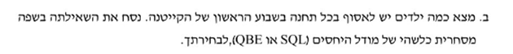

We can do the following:

A sub table that join child and pick-up which display additional column station_address near the child.

So we will get:

Roni, herzel, 6, 1, y , school

danny, herzel, 2, 1, y, school

mor, olive, 2, 3, y, pool

shai, olive, 6, 4, y, pool

hila, sprinchak, 6, 1, n, school

select * from child

inner join pick_up

on child.ch_address = pick_up.ch_address

Now we can do group by and count on that new relation

with result as

(

select * ,pick_up.station

from child

inner join pick_up

on child.ch_address = pick_up.ch_address

)

Select count(*) from result

group by result.station

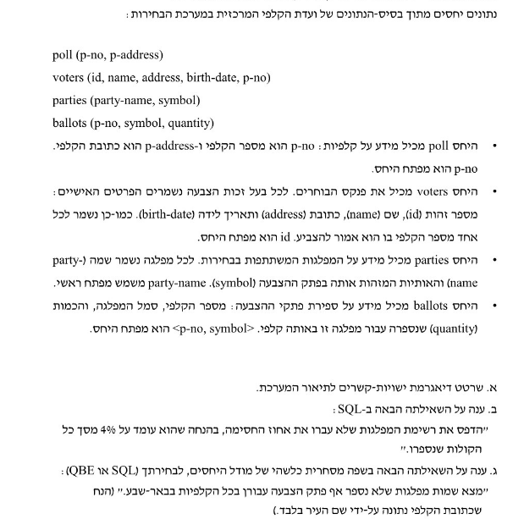

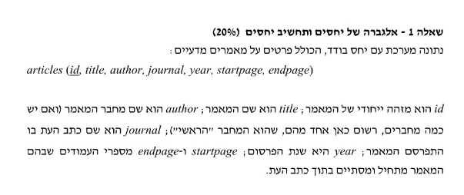

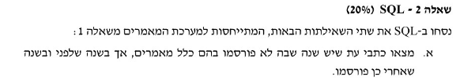

טבלת article

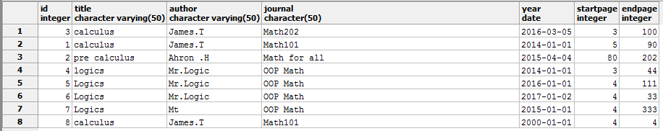

select subresult.* from (

select a1.title, EXTRACT(YEAR FROM a1.year) as "d1" , EXTRACT(YEAR FROM a2.year) as "d2" from article as a1, article as a2

where a1.journal = a2.journal and a1.id != a2.id ) as subresult

where d2-d1 = 2

The sub query:

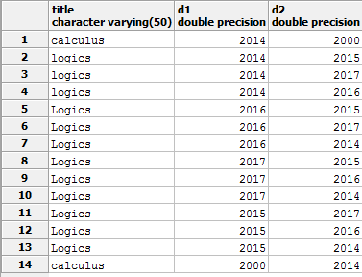

The result:

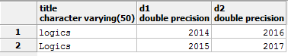

כאן משתמשים ב sub query אשר יחלץ את המאמרים אחד ליד השני כולל השנה שלהם

השימוש הוא שוב במכפלה קרטזית של אותה טבלה

על מנת לקבל את השדות באותה שורה בשביל

לבצע חיתוך עם where

ה sub query מקבל name subresult

ואז בודקים האם ההפרש בין השנים הוא 2



select * from (

select count(*) as c1 , author, journal from article

group by author, journal

having count(*) > 1) as a1 ,

(select count(*) as c2 , author from article

group by author

having count(*) > 1 ) as a2

where c1 = c2 and a1.author = a2.author

What we are getting in different group by is that one has three articles but in a different journal

So we will do a Cartesian product from then, filter by the same count and the same author.

The result will be only the author that published more then one article and only in the same journal.

The result:

